Portfolio Website Content:

**Welcome to My Portfolio**

Medication care that supports both recovery and life quality

**About Me**

My name is Rishi Tandon, I am a registered pharmacist who specializes in disability and rehabilitation treatment. I have a passion of assisting patients to become independent and confident with safe and individualized medication care. I have been working with rehabilitation teams to treat people who have experienced the spinal cord injuries, stroke, and other neurological conditions. I maintain effective communication with both patients and caregivers and I promote their dignity throughout the process. By volunteering in the community, I helped needy disabled people by providing them with free counseling and medications advice. These experiences still inform my faith in affordable and friendly healthcare to everyone.

**Rishi’s Unique Selling Point (USP)**

A pharmacist who specializes in disability and rehabilitation care, combining clinical expertise with deep empathy to help patients gain independence, dignity, and confidence in managing their health.

## Services

#### **Medication Therapy Management**

Optimizing medication plans to improve recovery outcomes, reduce side effects, and support long-term health.

#### **Rehabilitation Pharmaceutical Care**

Specialized care for patients with spinal cord injuries, stroke recovery, cerebral palsy, and neurological disabilities.

#### **Patient and Caregiver Education**

Clear guidance on safe medication use, adherence, and drug interactions to build confidence and independence.

## Capability Statement

### [Epidemiology and Data Analysis](https://68fd37bea80c1.site123.me/capability-statement/epidemiology-and-data-analysis)

* 26/10/2025 09:14 AM

### [Collaborative and Interdisciplinary Practice](https://68fd37bea80c1.site123.me/capability-statement/collaborative-and-interdisciplinary-practice)

* 26/10/2025 09:14 AM

### [Cultural Competency and Community Engagement](https://68fd37bea80c1.site123.me/capability-statement/cultural-competency-and-community-engagement)

* 26/10/2025 09:14 AM

### [Health Promotion and Program Delivery](https://68fd37bea80c1.site123.me/capability-statement/health-promotion-and-program-delivery)

* 26/10/2025 09:14 AM

## Testimonials

 He shows a strong commitment to ethical pharmacy practice and patient advocacy. I have seen him communicate with compassion even in challenging situations.

**Liam Peterson:**Clinical Supervisor

## Portfolio & Achievements

[[](https://68fd37bea80c1.site123.me/portfolio-achievements/gpat-entrance-exam)](https://68fd37bea80c1.site123.me/portfolio-achievements/gpat-entrance-exam" \o "GPAT Entrance Exam)

**[GPAT Entrance Exam](https://68fd37bea80c1.site123.me/portfolio-achievements/gpat-entrance-exam" \o "GPAT Entrance Exam)**

[[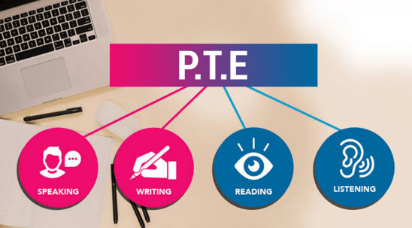](https://68fd37bea80c1.site123.me/portfolio-achievements/pte-academic)](https://68fd37bea80c1.site123.me/portfolio-achievements/pte-academic" \o "PTE Academic)

**[PTE Academic](https://68fd37bea80c1.site123.me/portfolio-achievements/pte-academic" \o "PTE Academic)**

## Academic Literature Reflections

#### Pharmacotherapy and the Role of Pharmacists in Rehabilitation Medicine

#### Analysis of Clinical Pharmacists' Interventions in a Rehabilitation Setting

#### Pharmacy Students' Attitudes Toward Persons With Disabilities

#### Improving Pharmacy Care for Patients With Disabilities

## Contact

* Sydney NSW, Australia
* [+61- 478 724 239](tel:+61-478724239)
* [rishitandon9k@gmail.com](mailto:rishitandon9k@gmail.com)
* Mon-Fri - 08:00-19:00